1. Face Detection Parameter Tuning
For our face detection pipeline, we utilized OpenCV's Haar Cascade Classifier (haarcascade_frontalface_default.xml). To optimize the detection accuracy for our specific webcam and dataset environments, we tested three different combinations of parameters for the detectMultiScale function: scaleFactor, minNeighbors, and minSize.
Test # | scaleFactor | minNeighbors | minSize | Result / Observation
Combo 1 | 1.05 | 3 | (20, 20) | High Sensitivity: Detected faces very easily, but resulted in too many "false positives" (e.g., detecting faces in background objects or patterned clothing).
Combo 2 | 1.2 | 8 | (50, 50) | Strict Detection: Eliminated all false positives, but struggled to detect faces if the user leaned back from the webcam or turned their head slightly.
Combo 3 | 1.1 | 5 | (30, 30) | Optimal Balance (Chosen): Provided the best trade-off. It reliably tracked the user's face in real-time without drawing bounding boxes on random background noise.

2. Edge Cases Handled
To ensure the pipeline is robust and does not crash during real-time or batch analysis, our code explicitly handles several edge cases:
- No Face Found: If the Haar Cascade fails to find a face (or the user steps out of the webcam frame), the detect_faces function safely returns an empty list []. Partner B's code checks for this and bypasses the DeepFace classification to prevent the program from crashing.
- Tiny Dataset Images (FER2013): During batch processing, images that are already tightly cropped (like the 48x48 pixel FER2013 dataset) are often too small for the Haar Cascade's minSize threshold. We built a fallback mechanism: if the face detector returns [] during batch mode, the system assumes the entire image is the face region and passes it directly to DeepFace for classification.
- Multiple Faces in Frame: The face detection function is designed to return a list of all bounding boxes found. Partner B's visualization loop iterates through every detected face, allowing the system to track and classify multiple people on screen simultaneously.
3. AI Evaluation & Batch Results (B3)
We evaluated our pipeline against a curated dataset of 140 images (20 per emotion) derived from the FER2013 dataset.
Overall Accuracy: 53%
Confusion Matrix Analysis:
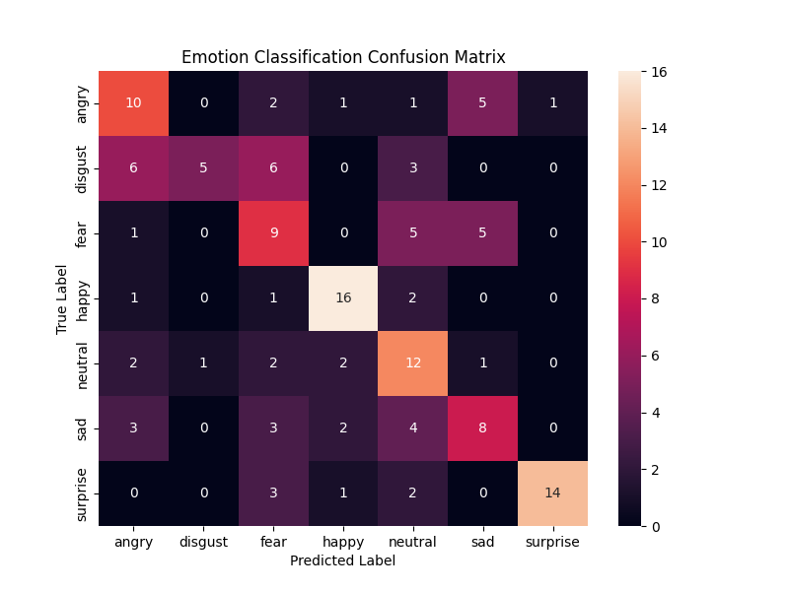
Looking at the confusion matrix, our model performed best at identifying Happy. The model struggled the most with distinguishing between Sad and Disgust likely because these expressions share similar physical traits, such as a relaxed jaw and neutral eyebrows.
Preprocessing Experiment: During testing, we discovered that forcing the AI to evaluate the A1 preprocessed images (Grayscale + CLAHE) actually dropped our accuracy significantly. DeepFace's neural networks are trained on natural color and lighting. The CLAHE algorithm artificially created harsh lines and shadows that the AI misinterpreted as facial wrinkles or unnatural distortions. Therefore, for optimal accuracy, we feed the raw color ROI directly to DeepFace.

